RocketCX

Enterprise Connector

Quick Start Deployment

December 2019

ECS

Contents

Overview 2

Cost and licenses 2

Architecture 3

Planning the deployment 3

Specialized knowledge 3

AWS account 4

Technical requirements 4

Deployment options 4

Deployment steps 4

Step 1. Setup AWS account and Amazon Connect Instance 4

Step 2. Download and Launch the Quick Start 5

Contact Flows 9

Best practices for using RocketCX Enterprise Connector for ServiceNow on AWS 9

Security 10

Git Repository 10

FAQ 10

Send us feedback 11

Additional resources 11

[Quick Starts](http://aws.amazon.com/quickstart/) are automated reference deployments that use AWS CloudFormation templates to deploy key technologies on AWS, following AWS best practices. This Quick Start was created by ECS in collaboration with Amazon Web Services (AWS).

# Overview

This Quick Start reference deployment guide provides step-by-step instructions for deploying customized lambda functions related to RocketCX Enterprise Connector for ServiceNow.

This Quick Start is for users who would like to explore the data dips API provided by RocketCXEnterprise Connector for ServiceNow.

RocketCX Enterprise Connector for ServiceNow quick start provides multiple customized lambda functions to display different data dip RESTful API endpoint calls.

## Cost and licenses

You are responsible for the cost of the AWS services used while running this Quick Start reference deployment. There is no additional cost for using the Quick Start.

The AWS CloudFormation template for this Quick Start includes configuration parameters that you can customize. This Quick Start only deploys lambda functions and some permissions on the AWS side, which do not incur any cost until the lambda functions are triggered. This Quick Start does not include any configuration parameters or deployment options for ServiceNow.

**Tip** After you deploy the Quick Start, we recommend that you enable the [AWS Cost and Usage Report](https://docs.aws.amazon.com/awsaccountbilling/latest/aboutv2/billing-reports-gettingstarted-turnonreports.html) to track costs associated with the Quick Start. This report delivers billing metrics to an S3 bucket in your account. It provides cost estimates based on usage throughout each month and finalizes the data at the end of the month. For more information about the report, see the [AWS documentation](https://docs.aws.amazon.com/awsaccountbilling/latest/aboutv2/billing-reports-costusage.html).

# Architecture

Deploying this Quick Start for a new virtual private cloud (VPC) with **default parameters** builds the following quick start environment in the AWS Cloud.

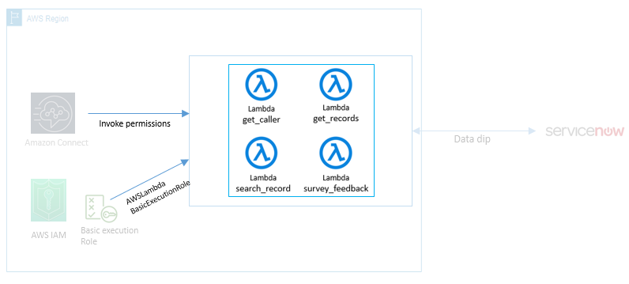

Figure 1: Quick Start architecture for RocketCX Enterprise Connector for ServiceNow on AWS

The Quick Start sets up the following:

• Four lambda functions for data dip operations

• Attaches an AWS managed basic lambda execution role to all lambda functions, which allows AWS Lambda to create Amazon CloudWatch logs

• Permissions for your Amazon Connect instance to invoke the AWS Lambda functions

# Planning the deployment

## Specialized knowledge

This deployment guide requires a moderate level of familiarity with the below mentioned AWS services. If you are new to AWS, visit the [Getting Started Resource Center](https://aws.amazon.com/getting-started/)

* [Amazon Connect](https://aws.amazon.com/connect/)
* [AWS Lambda](https://aws.amazon.com/lambda/)
* [AWS CloudFormation](https://docs.aws.amazon.com/cloudformation/index.html)

## AWS account

If you do not already have an AWS account, create one at [https://aws.amazon.com](https://aws.amazon.com/) by following the on-screen instructions. Part of the sign-up process involves receiving a phone call and entering a PIN using the phone keypad.

Your AWS account is automatically signed up for all AWS services. You are charged only for the services you use.

## Technical requirements

Before the deployment of lambda funtions it is recommended to [setup an Amazon Connect](https://docs.aws.amazon.com/connect/latest/adminguide/amazon-connect-get-started.html) instance in AWS.

It is also recommended to use an IAM user with full permissions on Amazon Connect, Lambda, CloudFormation and IAM.

## Deployment options

This Quick Start deploys AWS Lambda functions and associated permissions.

These lambda functions are recommended to deploy out of VPC, because functions require access to service now instance over internet.

# Deployment steps

## Step 1. Setup AWS account and Amazon Connect Instance

We recommend using US East (N. Virginia) region for the following steps:

1. Sign in to your AWS account at <https://aws.amazon.com> with an IAM user role that has the necessary permissions. For details, see Planning the deployment earlier in this guide.
2. Make sure that your AWS account is configured correctly, as discussed in the Technical requirements section.
3. Setup new Amazon Connect Instance if you do not already have one in US East region refer link to setup new instance [Create New Amazon Connect Instance](https://docs.aws.amazon.com/connect/latest/adminguide/amazon-connect-get-started.html#launch-contact-center).

## Step 2. Download and Launch the Quick Start

**Notes** You are responsible for the cost of the AWS services used while running this Quick Start reference deployment. There is no additional cost for using this Quick Start. For full details, see the pricing pages for each AWS service you will be using in this Quick Start. Prices are subject to change.

1. Download resources from this link : [RockerCX_Lambda_CloudFormation](https://rocketcx.s3.amazonaws.com/EnterpriseConnectorforServiceNow/v1/CloudFormation/Public/RocketCX-CloudFormation.yml)
2. Set the region to US EAST (N. Virginia)

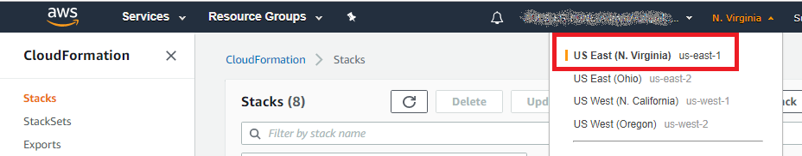

Figure 2: Change region to us-east-1 for CloudFormation deployment.

1. Open CloudFormation Service in AWS console.

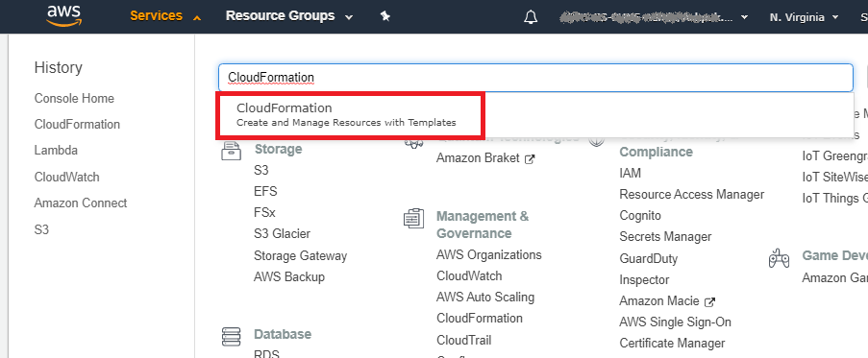

Figure 3: Change region to us-east-1 for CloudFormation deployment.

1. Click **Create Stack**.

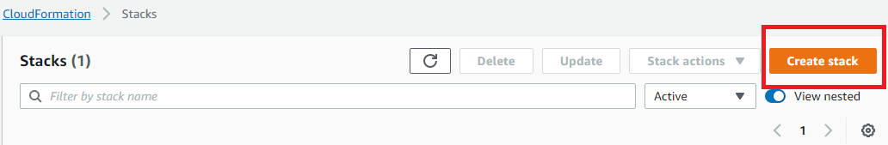

Figure 4: Create a new stack using CloudFormation service in AWS

Select options as per following screen and click **Choose file** to select downloaded CloudFormation template. Keep other options as default.

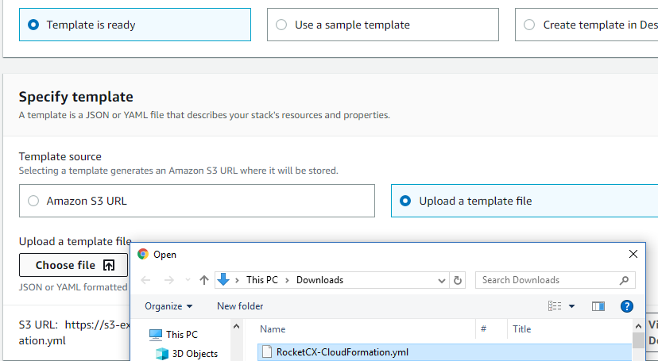

Figure 5: Select CloudFormation template from downloaded resources on ‘Specify template’ page

Click **Next**.

Add the flowing details on **Parameters** page and Follow all default setting on stack configuration until you reach final page.

CloudFormation parameter details

|  |  |  |
| --- | --- | --- |
| Parameter Name (name) | Details | Example |
| pServiceNowHost | The access URL for your ServiceNow Instance | https://my-instance.service-now.com/ |
| pServiceNowUserName | The name of the user that will make the API requests | User created during RocketCX installation on ServiceNow as per RocketCX Installation and Configuration Guide, section  (Setup ServiceNow user for RocketCX API Access) |
| pServiceNowPassword | The password for the username you have chosen for the API requests | User created during RocketCX installation on ServiceNow as per RocketCX Installation and Configuration Guide, section  (Setup ServiceNow user for RocketCX API Access) |
| pConnectInstanceId | pseudo-random character string to identify your instance for permission to the Lambdas | Details as shown in below picture |

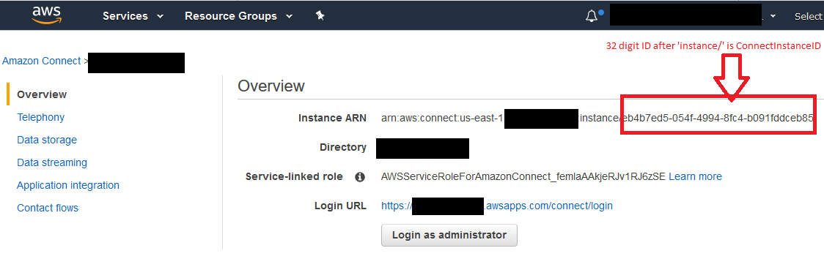

Figure 6: CloudFormation parameter pConnectInstanceId is present in Instance ARN of Amazon Connect instance

Follow all default settings on the stack configuration, along with above-mentioned configuration until you reach final page. Once at the final page, select all checkboxes as show in the following screenshot and click ‘create stack’

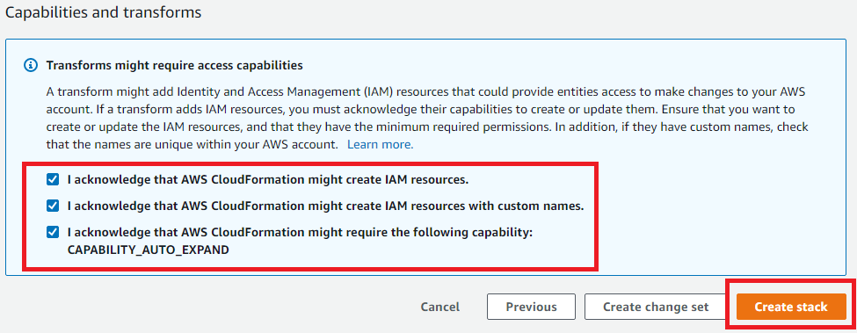

Figure 7: Configure stack with default settings and select all checkbox to proceed with create stack.

Upon successful deployment, please take note of the Output variables from the stack. Values for these variables can be used during integrating the deployed lambda functions with contact flows.

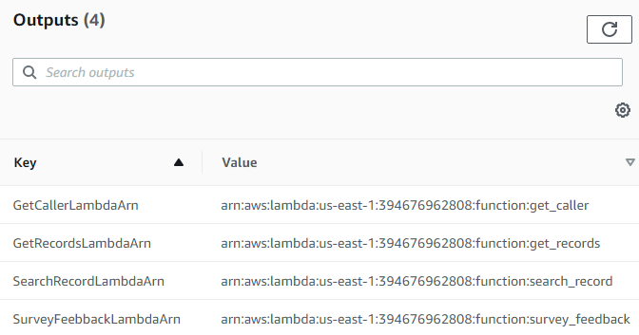

Figure 8: CloudFormation stack output after successful deployment of stack.

**Notes** This guide doesn’t not include steps for consuming deployed lambda function in contact flows.

# Contact Flows

Should you need contact flows for testing the integration, please refer to the [deploy contact flow document](ttps://rocketcx.s3.amazonaws.com/EnterpriseConnectorforServiceNow/v1/Documents/Public/RocketCX+Contact+Flow+Deployment+Guide.docx) for a quick deployment of contact flows.

# Best practices for using RocketCX Enterprise Connector for ServiceNow on AWS

1. It is recommended to deploy the lambda functions in US East (N. Virginia) us-east-1 region.
2. It is best practice to reduce the number of lambda function invocations for a single call - this can be avoided by collecting as much information as possible in single lambda call.
3. Before calling the API provided by the RocketCX Enterprise Connector for ServiceNow, it is best practice to validate all user input to avoid unnecessary API invocations.

# Security

The related CloudFormation template deploys four lambda functions for data dip operations and attaches an AWS managed basic lambda execution role to all lambda functions, which allows AWS Lambda to create Amazon CloudWatch logs. If you are adding more functionality to existing lambda functions, which interact with other AWS services, then it is recommended to change the lambda permissions to allow interactions with those services.

The CloudFormation template allows the Amazon Connect instance, specified as a parameter, to trigger lambda functions. If you are looking to integrate deployed lambda functions with other Amazon Connect instances, then you need to manually add permissions for the Amazon Connect instance to trigger lambda functions. Refer [Amazon Connect with Lambda](https://docs.aws.amazon.com/connect/latest/adminguide/connect-lambda-functions.html)

# Git Repository

You can visit our [Git repository](https://github.com/aws-quickstart/quickstart-ecs-uk-rocketcx) to download code or send us feedback.

# FAQ

**Q.** I encountered a CREATE_FAILED error when I launched the Quick Start.

**A.** If AWS CloudFormation fails to create the stack, we recommend that you relaunch the template with **Rollback on failure** set to **No**. (This setting is under **Advanced** in the AWS CloudFormation console, **Options** page.) With this setting, the stack’s state will be retained and the instance will be left running, so you can troubleshoot the issue. (For Windows, look at the log files in %ProgramFiles%\Amazon\EC2ConfigService and C:\cfn\log.)

**Important** When you set **Rollback on failure** to **No**, you will continue to incur AWS charges for this stack. Please make sure to delete the stack when you finish troubleshooting.

For additional information, see [Troubleshooting AWS CloudFormation](https://docs.aws.amazon.com/AWSCloudFormation/latest/UserGuide/troubleshooting.html) on the AWS website.

**Q.** I encountered a size limitation error when I deployed the AWS CloudFormation templates.

**A.** We recommend that you launch the Quick Start templates from the links in this guide or from another S3 bucket. If you deploy the templates from a local copy on your computer or from a non-S3 location, you might encounter template size limitations when you create the stack. For more information about AWS CloudFormation limits, see the [AWS documentation](http://docs.aws.amazon.com/AWSCloudFormation/latest/UserGuide/cloudformation-limits.html).

# Send us feedback

To post feedback, submit feature ideas, or report bugs, use the **Issues** section of the [GitHub repository](https://github.com/aws-quickstart/quickstart-ecs-uk-rocketcx) for this Quick Start. If you’d like to submit code, please review the [Quick Start Contributor’s Guide](https://aws-quickstart.github.io/).

# Additional resources

AWS resources

* [Getting Started Resource Center](https://aws.amazon.com/getting-started/)
* [AWS General Reference](https://docs.aws.amazon.com/general/latest/gr/)
* [AWS Glossary](https://docs.aws.amazon.com/general/latest/gr/glos-chap.html)

AWS services

* [AWS CloudFormation](https://docs.aws.amazon.com/cloudformation/)
* [IAM](https://docs.aws.amazon.com/iam/)
* [Amazon Connect](https://aws.amazon.com/connect/)